|  |  |  |  |  |  |
| --- | --- | --- | --- | --- | --- |
| Kepada | : | Pimpinan | Tanggal | : | 21 November 2024 |
| Dari | : | Departemen IT | CC | : | IC |

**Perihal :** ***Monitoring Sensor Suhu Oven Produksi Kerupuk***

1. **Latar Belakang Pengajuan**

Sehubungan dengan adanya pengembangan pembahasan terkait Monitoring Sensor Suhu di Oven Produksi Kerupuk, pihak IT ingin mengajukan pembelian sparepart alat sensor yang di butuhkan.

1. **Detail / Bentuk Pengajuan**

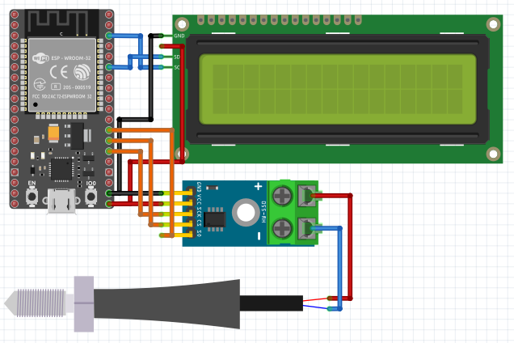

|  |  |  |  |  |
| --- | --- | --- | --- | --- |
| **No** | **Nama Barang** | **Spesifikasi** | **Jumlah Unit** | **Jumlah (Rp.)** |
| 1 | **ESP32 Development Board Nodemcu ESP 32 Type C USB C Dev Kit V1 DOID**    <https://tokopedia.link/NCqfjBviaLb> | - Microcontroller : ESP32 model -> ESP-12 - Flash : 4MB - Clock Speed : 80Mhz/160Mhz - Operating Voltage : 3.3 V - USB Interface : CH340G (driver dapat dicari di google) - USB Port : Micro USB (sama seperti port HP Android) - Port : GPIO (dapat berfungsi sebagai GPIO , PWM, ADC. I2C,)  **Harga : Rp 63.000** | 2 | Rp126.000 |
| 2 | **Thermocouple Probe Type K Drat M8 1.25mm Thermocouple Model Probe - 200mm, Kabel 2 Meter**    <https://tokopedia.link/ax1MjatiaLb> | Specifications : - Pilihan Ukuran Kepala : 30mm, 50mm, 100mm, 150mm, 200mm - temperature range : 0°C to 400°C - accuracy : +/- 2.2°C - panjang kabel : 2 meter / 5 meter - drat baut : Kasar 1.25mm (M8)  **Harga : Rp 60.000** | 2 | Rp120.000 |
| 3 | **LCD 16x2 Biru Blue 1602 SPI I2C Backpack**    <https://tokopedia.link/lngC6BriaLb> | ++ Model: YB1602A ++ Dot Matrix: 16x2 ++ Ukuran: 80mm x 36mm x 12.5mm ++ Ukuran Tampilan: 64.5mm x 13.8/16.0mm ++ Kontroller: SPLC780C atau EQV ++ Voltase: 5.0V/3.3V  **Harga : Rp 22.500** | 2 | Rp45,000 |
| 4 | **lm2596 module converter buck lm2596s step down display voltmeter**    <https://tokopedia.link/pn9aIFnjaLb> | Jumlah pin: 2 Pitch: 5mm Warna: Biru  **Harga : Rp. 14,800** | 2 | Rp29.600 |
| 5 | **[CNC] K-TYPE THERMOCOUPLE MAX6675 HIGH TEMPERATURE SENSOR FOR ARDUINO**    https://www.tokopedia.com/cncstorebandung/cnc-k-type-thermocouple-max6675-high-temperature-sensor-for-arduino | MAX6675 type Thermocouple Temperature Sensor Temperature 0-800 Degrees Module  **Harga: Rp. 28.900** | 2 | Rp.57.800 |
| 6 | **CONNECTOR XH2.54 2P PIN FEMALE 20CM CABLE JST 2.54MM SOCKET CON STOCKO**    https://www.tokopedia.com/cncstorebandung/connector-xh2-54-2p-pin-female-20cm-cable-jst-2-54mm-socket-con-stocko | Konektor JST 2.54 2 Pin 20 CM  **Harga : Rp1,000** | 6 | Rp 6,000 |
| 7 | **Adaptor adapter Jack 220v AC to 9V 2A DC switching power supply**    <https://tokopedia.link/UWSpiv1laLb> | Input : 100V-240V 50/60Hz Output : DC 9V 1A /1000mA Out put adaptor : 5.5mm x 2.1mm Dimension: 7.6 x 7.5 x 2.6 cm Length of the cable: 110CM  **Harga : Rp20,500** | 2 | Rp 41,000 |
| 8 | **BOX ELEKTRONIK X4 KOTAK RANGKAIAN ARDUINO 12.5x8.5x5 CASING BLACK X-4**    <https://tokopedia.link/6dTjgyPQjKb> | - BOX Type : X4 - Dimensi : 12.5cm x 8.5 cm x 5cm - Bahan : Plastik Tebal Berkualitas (Tidak mudah pecah/cukup Kuat) - Warna : Hitam legam - Penginci : Skrup 5m (Tidak Include)  **Harga : Rp9,200** | 2 | Rp 18.400 |
| 9 | [**KABEL JACK DC FEMALE UNTUK ADAPTOR JARING POWER SUPPLY**](https://tokopedia.link/tomwz4ISxHb)    <https://tokopedia.link/fSiTRJQkaLb> | - Product Name : DC Connector; - Use for : CCTV Camera - Plug Type : 2.1 x 5.5mm FEMALE; - Material : Plastic, Electric Parts - Model: Push Type  **Harga : Rp1.200** | 2 | Rp 2.400 |
| 10 | **PCB DOT MATRIX THRU HOLE SINGLE LAYER 5X7CM 5*7CM LUBANG BOLONG MATRIK - SINGLE HOLE**    https://tokopedia.link/QlDCAmgqULb | - Ukuran : 5x7cm - Jumlah lubang : 16 x 24 = 432 lubang - Space : 2.54mm - Jenis: THRU HOLE - Warna: Green - Ketebalan : 1.4mm - Hole diameter : 0.9mm  **Harga: Rp. 2.900** | 2 | Rp. 5.800 |
| 11 | **CONNECTOR XH2.54 4P PIN FEMALE 20CM CABLE JST 2.54MM SOCKET CON STOCKO**    https://www.tokopedia.com/cncstorebandung/connector-xh2-54-2p-pin-female-20cm-cable-jst-2-54mm-socket-con-stocko | Konektor JST 2.54 4 Pin 20 CM  **Harga : Rp2,500** | 4 | Rp10.000 |
| 12 | **CONNECTOR XH2.54 3P PIN FEMALE 20CM CABLE JST 2.54MM SOCKET CON STOCKO**    https://www.tokopedia.com/cncstorebandung/connector-xh2-54-3p-pin-female-20cm-cable-jst-2-54mm-socket-con-stocko | Konektor JST 2.54 3 Pin 20 CM  **Harga : Rp1,500** | 4 | Rp6.000 |
| **Jumlah Total** | | | | **Rp423.400** |

1. **Kesimpulan & Penutup**

Dengan adanya project pembuatan Monitoring Sensor Suhu Oven Produksi Kerupuk ini diharapkan dapat meningkatkan efisiensi Departemen Produksi dalam rangka monitoring suhu.

----------------------------------------------------------------------------------------------------------------------------------------------------

|  |  |  |
| --- | --- | --- |
| Hormat Kami, |  | Pengajuan Disetujui : |
| Dibuat & Diajukan,  […………………..] | Diperiksa & Diketahui,  [………………….] | [………………….] |
|  |  | Catatan : |